COMP 4670/8600: Introduction to Statistical Machine Learning

Assignment I

Manab Chetia, u5492350

1. **Probabilities**
   1. **(2/20) Medical Test**
2. 0.078
3. Probability of disease, P(D) = 0.01

Probability that test is positive given person is diseased, P(+|D) = 0.8

Probability that test is positive given person is healthy, P(+|D’) = 0.095

Probability that person is diseased given test is positive, P(D|+) = ?

Using Bayes Theorem,

P(D|+) =

=

=

= 0.078

$8.08 × {10}^{-3}$

1. A person who is diseased but is detected healthy has a dangerous consequence, as there is a possibility the person spreads the disease to others; therefore it has the highest penalty of 1000.

A person who is healthy but is detected diseased is not much of a worry as there lies no threat of spreading the disease but there lies a low trouble as he has to undergo medical procedures which will take away precious time and effort. Hence a penalty of 1.

A person who is diseased and is detected diseased and a person who is healthy and is detected healthy are correctly diagnosed. Hence there are no penalties for both cases.

1. 2.09405
2. a) Diseased

b) Diseased

Let’s consider classes $C_{1} = Diseased (D)$ and $C_{2} = Healthy (D^{'})$.

Calculating losses,

$$L_{1}=L_{21}p\left(D^{'}\right)p\left(+ | D^{'}\right)=0.09405$$

$$L_{2}=L_{12}p\left(D\right)p\left(- | D\right)=2$$

As $L_{1}$ < $L_{2}$, therefore we choose

* 1. **(2/20) Maximum Likelihood (ML) and Maximum A Posteriori (MAP)**

$θ_{ML}= 8$

1. From Bayes’ theorem we know,

$$p\left(θ | x\right)= \frac{p(x|θ)p(θ)}{\int{p(x|θ)p(θ)dθ}}$$

Therefore we can write,

$$p\left(θ | X_{n}\right)= p\left(θ | x_{n}, X^{n-1}\right)= \frac{p(x_{n}|θ, X^{n-1})p(θ|X^{n-1})}{\int{p(x_{n}|θ, X^{n-1})p(θ|X^{n-1})dθ}}$$

1. We know,

$$p\left({θ|X}_{4}\right)= \frac{p\left(X_{4} | θ\right)p(θ)}{p(X_{4})}∝p(X_{4}|θ)p(θ)$$

As the i.i.d data have been already observed,

$$Likelihood=p\left(X_{4} | θ\right)= \prod_{i=1}^{n}{p\left(x_{i} | θ\right)= \frac{1}{8}}×\frac{1}{8}×\frac{1}{8}×\frac{1}{8}=0.00024$$

$$Prior= p\left(θ\right)=\frac{1}{10}=0.1$$

Therefore

$$Posterior p\left({θ|X}_{4}\right)∝0.00024×0.1=0.000024$$

4. $θ_{MAP}=\arg{\max_{θ}}p\left({θ|X}_{4}\right)= \arg{\max_{θ}}p\left(X_{4} | θ\right)p\left(θ\right)$

As $p\left(θ\right)$ is constant therefore,

* 1. **(3/20) Laplace Approximation**

1. $f\left(z\right)= z^{k}e^{\frac{-z^{2}}{2}}$

Mode $z_{0}= ±\sqrt{k}$

* Calculating second derivative of $f(z)$ at $z_{0}$ we get,
$$\frac{δ^{2}}{δz^{2}}\left(z^{k}e^{\frac{-z^{2}}{2}}\right)\left|z_{0}\right.= -2k e^{-k}{√k}^{k-2}$$

* Calculating precision A,

$$A= \frac{-d}{dz^{2}}\ln\left(f\left(z\right)\right)= \frac{k}{z^{2}}+1$$

As $k >0$, therefore $A > 0$

As second derivative of $f(z)$ at $z_{0}$ is negative as well as precision $A > 0$, Gaussian Approximation will be defined.

1. Mean = $\sqrt{k}$,

Variance = ${\left(\frac{k}{z^{2}}+1\right)}^{-1}$

1. *k* = 0.5, $z = 0.56563663050$

*k* = 3, $z = 2.03095809023$

*k* = 5, $z = 8.70187712346$

1. $e^{\frac{-z^{2}}{2}}$ is a steeply decreasing function as $z$ increases. As $z$ increases, most values will be .
2. Plots

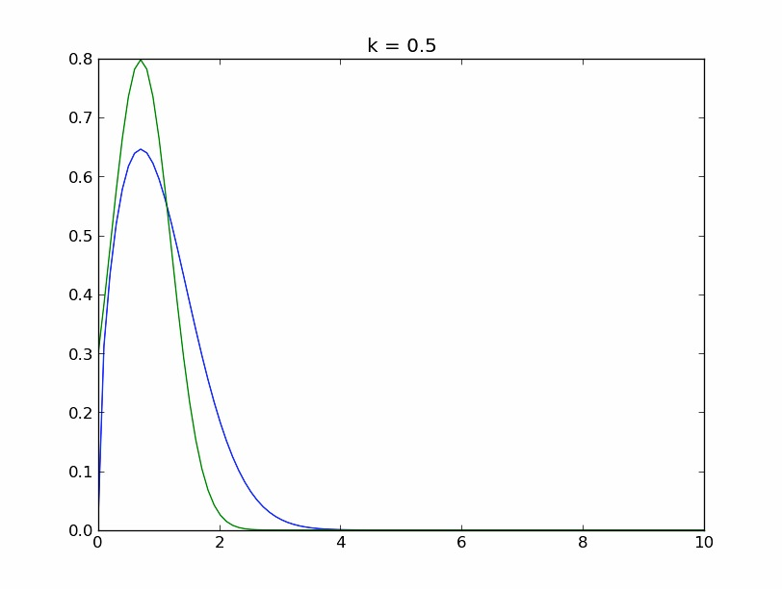

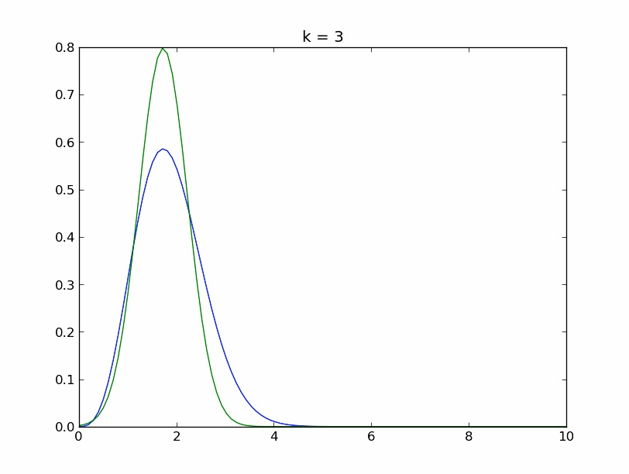

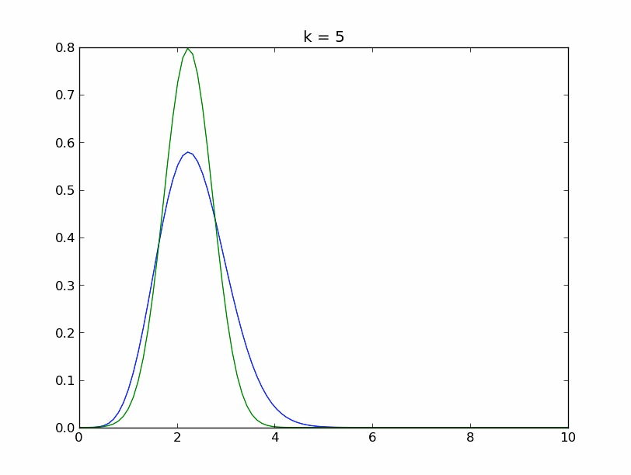

* 1. **(3/20) Bayesian Linear Regression**

1. ${(A+vv^{'})}^{-1} = A^{-1}- \frac{(A^{-1}v)(v'A^{-1})}{1 + v'A^{-1}v}$

Multiplying both sides by $(A + vv’),$ we get

$I= A^{-1}\left(A+vv^{'}\right)-$ $\frac{(A^{-1}v)(v'A^{-1})}{1 + v'A^{-1}v} (A+vv^{'})$

Considering only RHS,

$A^{-1}\left(A+vv^{'}\right)-$ $\frac{(A^{-1}v)(v'A^{-1})}{1 + v'A^{-1}v}\left(A+vv^{'}\right)$

= $I+ A^{-1}vv^{'}- \frac{(A^{-1}v)(v'A^{-1})}{1 + v'A^{-1}v} \left(A+vv^{'}\right)$

= $I+\frac{A^{-1}vv^{'}\left(1 + v'A^{-1}v\right)-(A^{-1}v)(v^{'}A^{-1})(A+vv^{'})}{1 + v^{'}A^{-1}v}$

= $I+\frac{A^{-1}vv^{'}\{I\left(1 + v^{'}A^{-1}v\right)-A^{-1}\left(A+vv^{'}\right)\}}{1 + v'A^{-1}v}$

= $I+\frac{A^{-1}vv^{'}\{\left(I + v^{'}A^{-1}v\right)-\left(I+vv^{'}A^{-1}\right)\}}{1 + v'A^{-1}v}$

= $I+\frac{A^{-1}vv^{'}\{\left(I +vv^{'}A^{-1}\right)-\left(I+vv^{'}A^{-1}\right)\}}{1 + v'A^{-1}v}$

= $I+\frac{A^{-1}vv^{'}*0}{1 + v'A^{-1}v}$

= $I$

Therefore L.H.S = R.H.S

1. We are given $σ_{N}^{2}$ = $\frac{1}{β}+ ϕ{\left(x\right)}^{'}S_{N}ϕ\left(x\right)$ where $S_{N}^{-1}= αI + βϕ’ϕ$

Let’s assume variance of noise σ2v = and A =

Therefore,

… (a)

$A =$ $σ_{v}^{-2}$ ϕ’ϕ $+ αI$

So we can write

… (b)

$$σ_{N}^{2}= σ_{v}^{2} + ϕ{\left(x\right)}^{'}A^{-1}ϕ\left(x\right)$$

To compute $A^{-1}$ we use,

$${(A+{vv}^{'})}^{-1}=A^{-1}-\frac{(A^{-1}v)(v'A^{-1})}{1 + v'A^{-1}v}$$

We have a set of data set of N data points and adding a new data point (xN+1, tN+1).

Rewriting $(a)$ for $(N+1)$ points we get,

$$A_{N+1}= A_{N} + σ_{v}^{-2}ϕ’\left(x^{N+1}\right) ϕ(x^{N+1}) + αI$$

Therefore inverse of $A_{N+1}$,

$${A_{N+1}^{-1}=A}_{N}^{-1}- \frac{A_{N}^{-1}ϕ(x^{N+1})ϕ^{'}(x^{N+1})A_{N}^{-1}}{σ_{v}^{2} + ϕ^{'}(x^{N+1})A_{N}^{-1}ϕ(x^{N+1})}$$

… (c)

Substituting (c) in (b), we get,

$$σ_{N+1}^{2}\left(x\right)= σ_{N}^{2}\left(x\right)- \frac{{\left[ϕ^{'}\left(x^{N+1}\right)A_{N}^{-1}\left(x\right)\right]}^{2}}{σ_{v}^{2}+ ϕ^{'}\left(x^{N+1}\right)A_{N}^{-1}ϕ\left(x^{N+1}\right)}$$

… (d)

From (d), we can write $σ_{N+1}^{2}\left(x\right)≤ σ_{N}^{2}\left(x\right)$

1. This inequality represents if extra data points are added, variance of output predictions will never be larger than any subset of those points.

**2. Dimensionality Reduction**

**2.1 Projection with Fisher's Discriminant**

1. [ [-0.00648404 0.0002029 0.01656621 0.00464915]

[-0.01199644 0.01822157 0.00289538 -0.0118346 ]

[ 0.01720897 -0.00784518 0.00506389 -0.01386845]

[ 0.02197205 0.02390111 -0.02562052 0.02471579] ]

2.a $Eigen Values = 3.21919292e+01 2.85391043e-01$

$Eigen Vectors= [-0.20874182 0.00653196 0.53331926 0.14967115]$,

$\left[-0.38620369 0.58661055 0.09321156 -0.38099366\right]$

2.b 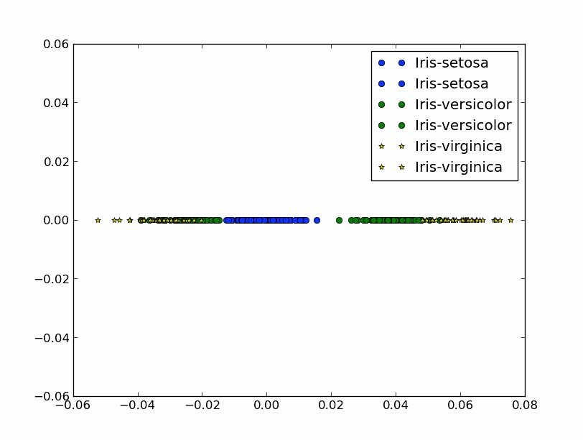

2.c The largest eigenvalue is 32.19, which is more than 110 times bigger than the next largest eigenvalue of 0.289. When projecting the 4 dimensional data into a 2 dimensional space defined by the eigenvectors (related with the 2 largest eigenvalues) we will get the maximum separation between the classes when projected in this 2D plane. However, the hyper plane associated with largest eigenvector ($λ=32.19$) will separate the data more than the hyper plane associated with eigenvector .289.

4. for is

Same as 2.2.b

|  |  |  |  |
| --- | --- | --- | --- |
| **Planes** | **Associated Eigenvalues** | | **J** |
| **1** | 32.19 | 0.285 | 32.477 |
| **2** | 32.19 | -1.80e-15 | 32.191 |
| **3** | 32.19 | 7.62e-15 | 32.191 |
| **4** | 0.285 | -1.80e-15 | 0.285 |
| **5** | 0.285 | 7.62e-15 | 0.285 |
| **6** | -1.80e-15 | 7.62e-15 | 5.82e-15 |

From this table, we can see J associated with the largest eigenvalues are the maximum and the eigenvectors related with the largest J provides the maximum separation between the classes.

**3. Cross Validation and Classification**

3.

|  |  |
| --- | --- |
| **S** | ***k* at which minimum errors occurs** |
| 2 | 1 |
| 5 | 25 |
| 10 | 11 |

In case of several *k* having the same lowest error, we choose the largest of those *k* as we are averaging over more neighbors and the effective decision boundary is more smoother which prevents over-fitting.

4. As *S* increases, for each *k*, misclassification error decreases.

As *S* increases, number of samples in training set increases and number of samples for validation set decreases.

As a result, when *S* is large, more training data is there to give rise to a better generalization model. Also as size of cross validation set decreases, the model better estimates the cross validation points. Hence, fewer errors as S increase.

5. Optimal *k* increases at first and then decreases as *S* increases.

First, when *S* is small, we have less training data. When we have less training data, less number of points are scattered over the entire space. Therefore the optimal value of *k* is also less because:

* Number of neighbors is small.
* When a larger value of k is chosen, it leads to misclassification due to under-fitting of data.

Therefore minimum error occurs when we average over a small set of neighbors. Therefore we have a smaller optimal *k* when *S* is small.

As *S* increases, size of training data set increases, therefore giving rise to much more prominent neighbors. Consequently now we can average over a higher number of neighbors for a better generalization. As a result optimal *k* increases.

As *S* increases further, size of cross validation set reduces and size of training set increases. With the further increase in *S*, there are more number of neighbors to calculate the distance metric, leading to higher generalization. As the number of neighbors increases, the optimal value of *k* decreases because availability of more number of training points results in better estimation with lesser value of *k*.

6. Python code filename: *u5492350_ManabChetia_kNN.py*